EWS application

# Create an App registration

An application must be registered in Azure Active Directory prior to running the script.

1. Open the Azure AD [portal](https://aad.portal.azure.com/#blade/Microsoft_AAD_IAM/ActiveDirectoryMenuBlade/Overview) and go to *App registrations*
2. Select *New registration*
3. Provide a name for your application and select *Register*

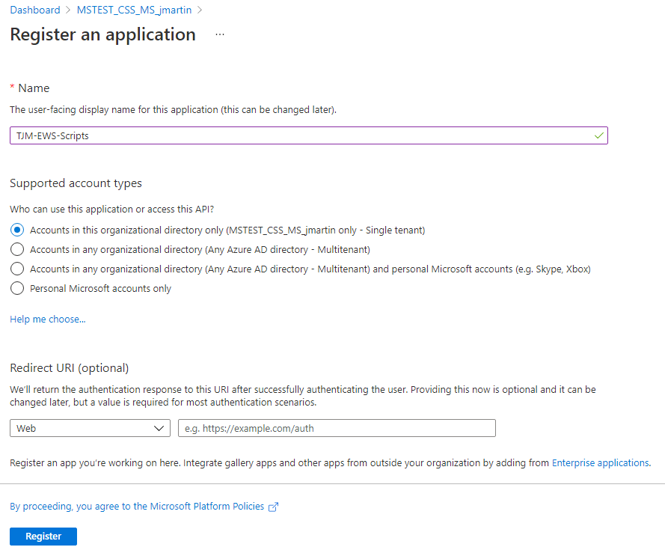

1. Copy the Application (client) ID and the Directory (tenant) ID for later use

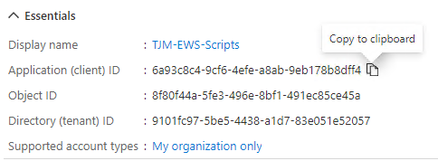

1. Select *Add a certificate or secret*
2. Select *New client secret* under the *Client secrets* section
3. Enter a *Description* and select a duration under the *Expires* drop-down menu

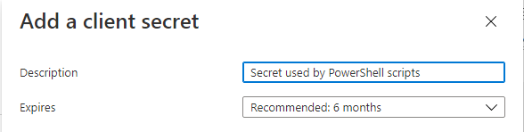

1. Copy the Value for your new client secret

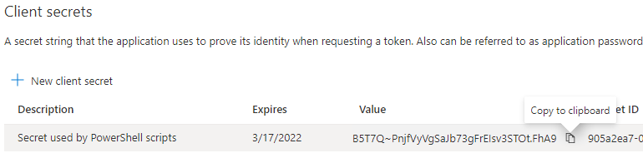

1. Select *Manifest* under the *Manage* options
2. Locate the *requiredResourceAccess* section and add the following:

{

"resourceAppId": "00000002-0000-0ff1-ce00-000000000000",

"resourceAccess": [

{

"id": "3b5f3d61-589b-4a3c-a359-5dd4b5ee5bd5",

"type": "Scope"

},

{

"id": "dc890d15-9560-4a4c-9b7f-a736ec74ec40",

"type": "Role"

},

{

"id": "dc50a0fb-09a3-484d-be87-e023b12c6440",

"type": "Role"

}

]

},

1. The Manifest should look like the following:

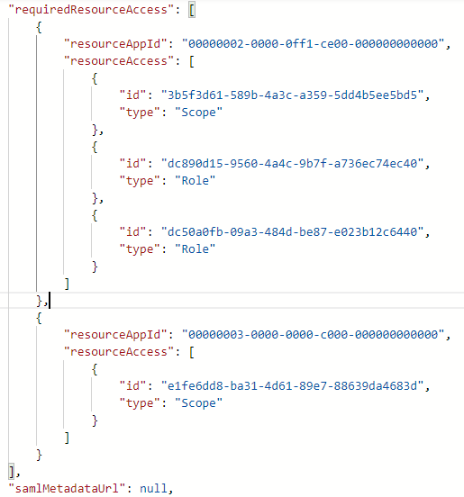

1. Click Save
2. Select *API* *permissions* under the *Manage* options
3. The Configured permissions will vary based on your tenant. There should be an API for Office 365 Exchange Online listed.

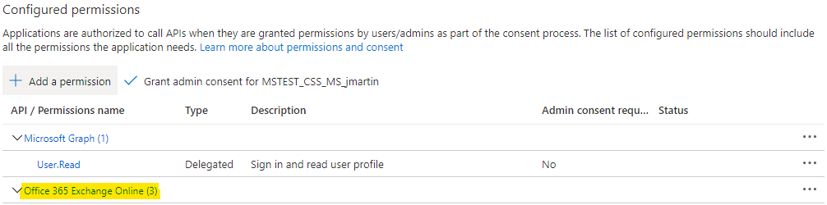

1. Select Office 365 Exchange Online to modify the permissions for the API
2. On the Request API permissions page, select full_access_as_app and select Update permissions

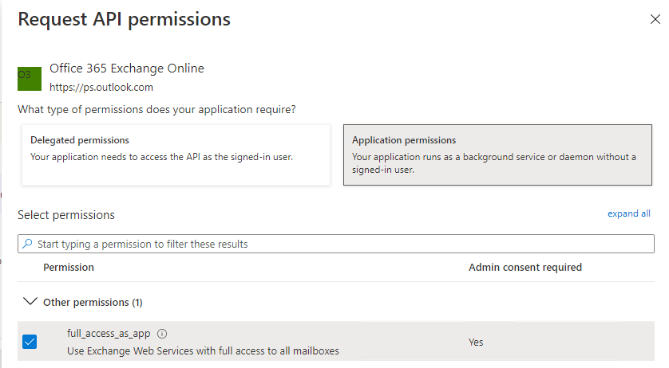

1. Select Grant admin consent for <Tenant name>

